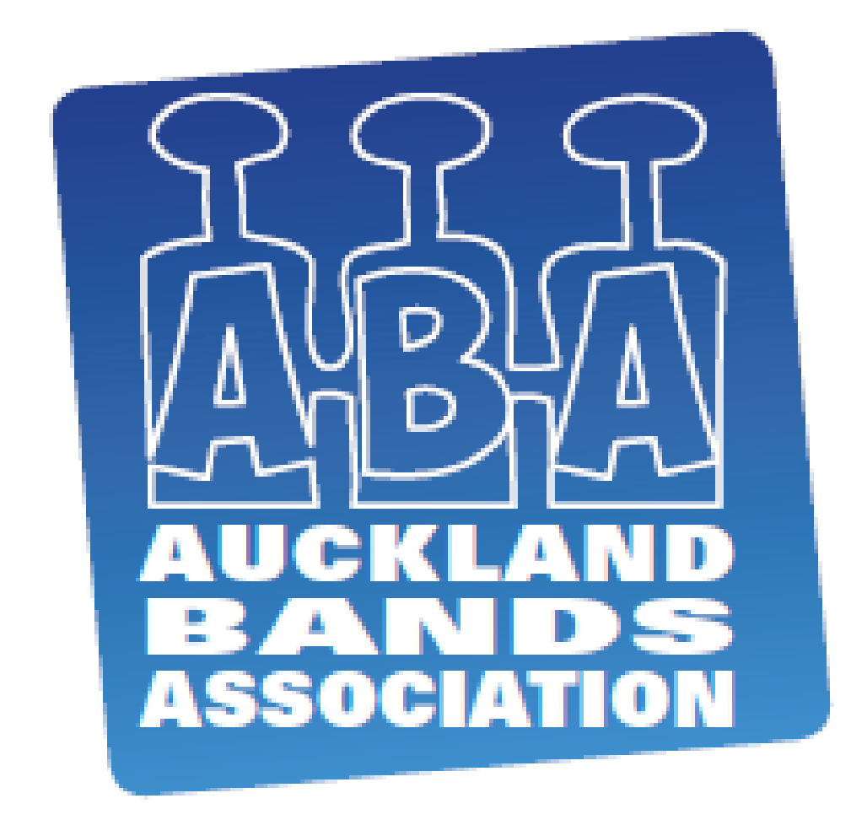
AUCKLAND BANDS ASSOCIATION

Declaration of Assisting Musicians

___________________________________________Band

Will be using the following Assisting Musicians during the
2015 ABA Band Contest.

Players Name: _________________________________________________

Band Registered with: ___________________________________________

Players Name: _________________________________________________

Band Registered with: ___________________________________________

Signed on behalf of the Band making the declaration: ___________________

Please print name: ______________________________________________

Position in the Organisation:______________________ Date / / __

Please forward to:
Auckland Band Association, PO Box 5219, Wellesley Street, Auckland, 1141 to arrive no later than Friday, 9th October 2014.

D Grade Bands only are entitled to a total of four Assisting Musicians being 2 players of any grade AND 2 additional players of no more than one grade above their own grade.

Players Name: _________________________________________________

Band Registered with: ____________________________________________

Players Name: _________________________________________________

Band Registered with: ____________________________________________

